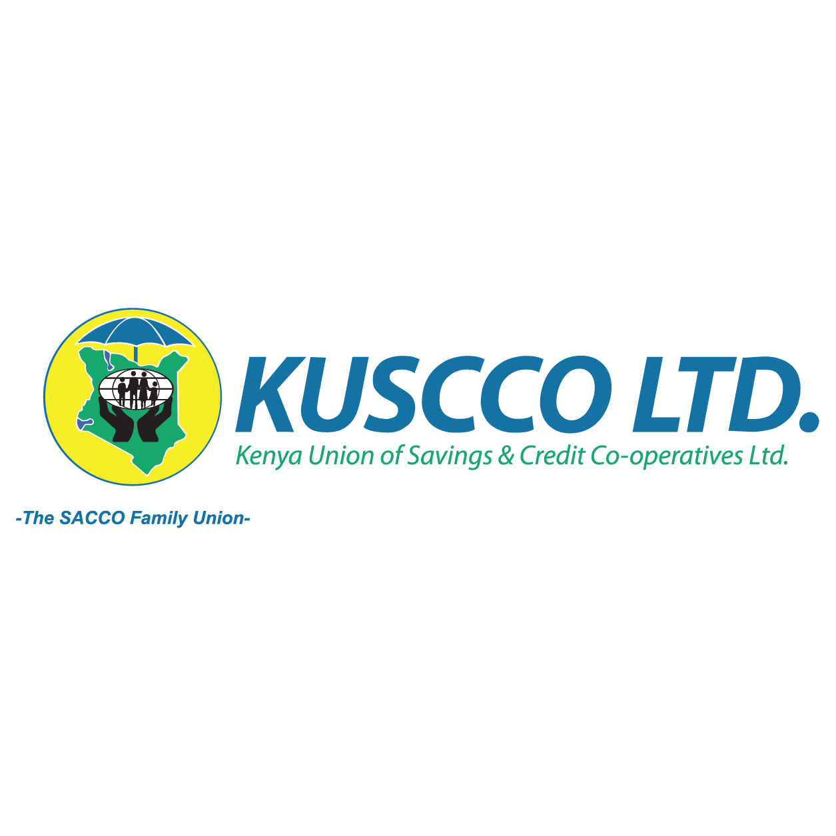**KUSCCO Limited Seeking a Skilled Transactions Adviser for Capital Raising and Share Offloading**

**KUSCCO Limited** (Kenya Union of Savings and Credit Cooperatives Limited) is a central organization that represents and provides services to Savings and Credit Cooperative Societies (SACCOs) in Kenya. Established to promote and advocate for SACCOs, KUSCCO plays a significant role in supporting the growth and sustainability of these financial institutions. KUSCCO Limited has interest in Insurance with a strong subsidiary KUSCCO Mutual Assurance Limited. We are seeking a trusted **transactions adviser** to guide us through the process of offloading shares and raising capital for our **insurance subsidiary (KMAL)**.

**We Need Expertise in:**

* **Share Offloading**
* **Capital Raising**
* **Valuation & Market Insights**
* **Transaction Structuring & Negotiation**
* **Regulatory Compliance & Risk Management**

**What We’re Looking for:**

* **Proven Experience:** A track record of successfully advising businesses in the insurance sector on similar transactions.
* **In-Depth Knowledge:** Expertise in the financial, regulatory, and market dynamics specific to the insurance industry.
* **Strategic Insight:** A results-oriented adviser who can help us achieve our capital raising goals and maximize the value of the share offload.
* **End-to-End Support:** Comprehensive assistance from the initial planning phase to the final execution of the transaction.

**If you’re an experienced transactions adviser with a passion for the insurance sector, we want to hear from you.**

Email: [info@kuscco.com](mailto:info@kuscco.com)